Paper name: Testar – scriptless testing through graphical user interface
Paper DOI: https://doi.org/10.1002/stvr.1771
Team members: Diaconu Ana-Maria, Duma Amalia-Diana, Draghiciu Diana
Testar has a dedicated website with a tab for downloading the tool. There you can also find a DIY hands on manuals where the installation steps are described. The installation process was fairly easy and intuitive and the graphical interface of the tool is pretty intuitive.
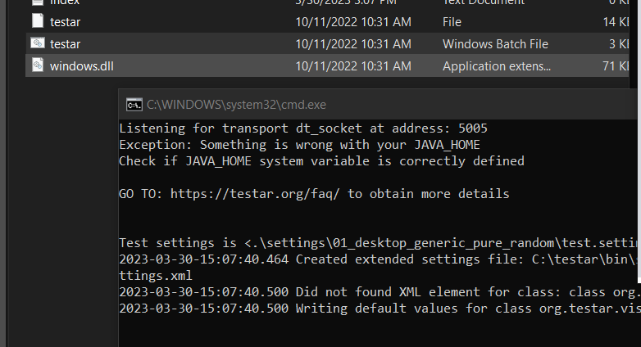
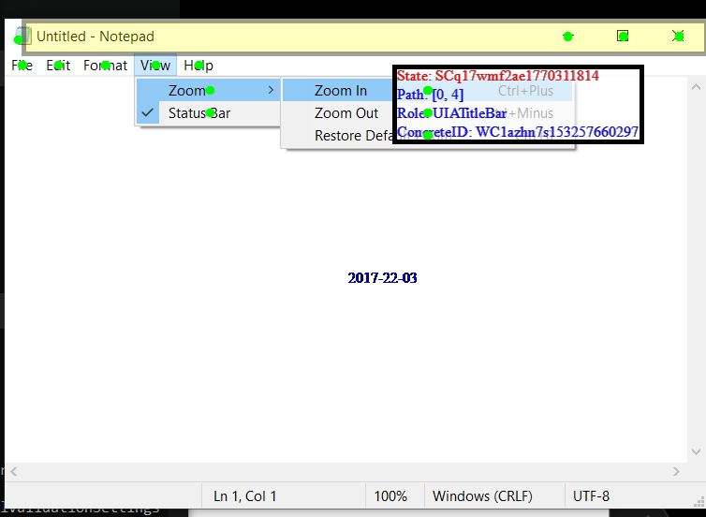

Testar in SPY mode in notepad
The tool is installed in the C directory where it can be run from a windows batch file. The JAVA_HOME exception was fixed afterwards. As shown in GUI, Testar has several execution modes, in order: SPY, GENERATE, RECORD, REPLAY, VIEW.
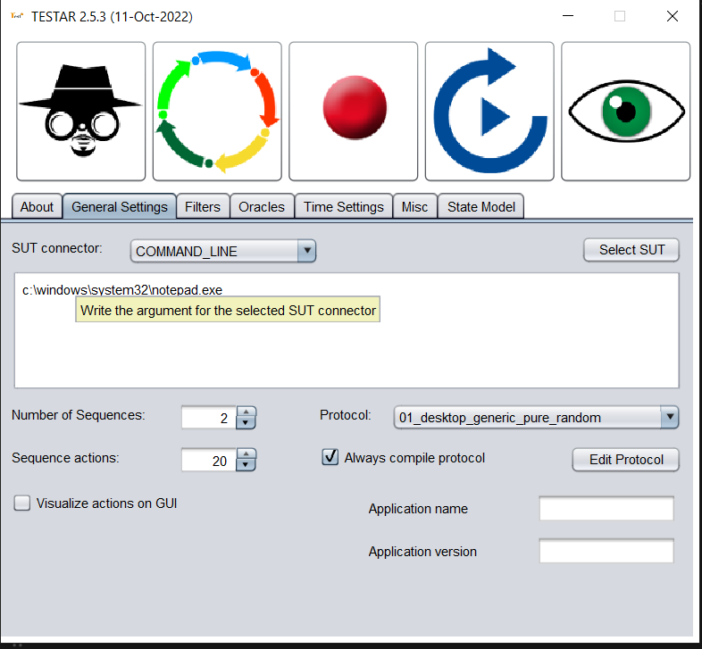
We begin with SPY mode which allows us to inspect the widget controls of the GUI. Here we see what actions TESTAR is able to extract and choose from. We configured the SUT connector to open the Notepad application.
Then, the automated testing is performed using the GENERATE mode. It includes a random selection of actions whose purpose is the violation of general-purpose system requirements. (the system under use should not crash, freeze, there shouldn’t be any widgets titled error, problem etc).
The results of the tests are displayed in an output directory where HTML reports as well as Text reports.
The main benefits of the tool consist of the scriptless testing it offers and how easy it is to automatically test almost every app with a GUI.
